

NAME :HAFZA WAQAS
REG NO : SP23-BSE-072
SUBJECT : ARTIFICAL INTELLIGENCE
LAB 02
TASK 1:
CODE: import math

# Leaf node values (left to right from your tree)
values = [-4, -5, 2, 3, 4, 5, 6, 7, 8, 0, 1, 8]
# Function to compute tree depth
def get_depth(values):
return math.floor(math.log(len(values), 2))
# Minimax function
def minimax(depth, index, is_max, values, max_depth):
# Base condition (leaf node)
if depth == max_depth:
return values[index]
# MAX level
if is_max:
left = minimax(depth + 1, index * 2, False, values, max_depth)
right = minimax(depth + 1, index * 2 + 1, False, values, max_depth)
return max(left, right)
# MIN level
else:
left = minimax(depth + 1, index * 2, True, values, max_depth)
right = minimax(depth + 1, index * 2 + 1, True, values, max_depth)
return min(left, right)
# Run algorithm
max_depth = get_depth(values)
result = minimax(0, 0, True, values, max_depth)
print("Final Minimax Value of Tree:", result)

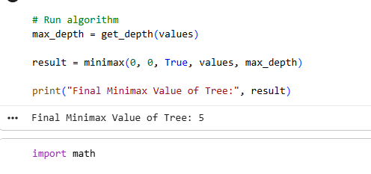

TASK 2
import math

def alphabeta(depth, index, is_max, values, max_depth, alpha, beta):
# Leaf node
if depth == max_depth:
return values[index]

if is_max:
best = -math.inf

left = alphabeta(depth + 1, index * 2, False, values, max_depth, alpha, beta)
best = max(best, left)
alpha = max(alpha, best)

if beta <= alpha:
return best # prune

right = alphabeta(depth + 1, index * 2 + 1, False, values, max_depth, alpha, beta)
best = max(best, right)
alpha = max(alpha, best)

return best

else:
best = math.inf

left = alphabeta(depth + 1, index * 2, True, values, max_depth, alpha, beta)
best = min(best, left)
beta = min(beta, best)
if beta <= alpha:
return best # prun
right = alphabeta(depth + 1, index * 2 + 1, True, values, max_depth, alpha, beta)
best = min(best, right)
beta = min(beta, best
return bes

# Example usage
values = [-4, -5, 2, 3, 4, 5, 6, 7, 8, 0, 1, 8]

max_depth = math.floor(math.log(len(values), 2))

result = alphabeta(0, 0, True, values, max_depth, -math.inf, math.inf)

print("Alpha-Beta Result:", result)

